**Question 1:** Print odd numbers in an array

**Solution:**

//Print odd numbers in an array

var num=[1,2,3,4,5,6,7,8,9,11,24,37]

**//Arrow Function**

var oddNumber=num.filter(arr => arr%2!==0)

**//anonymous function**

var oddNumber=num.filter(function (arr){

return arr%2!==0

})

console.log(oddNumber)

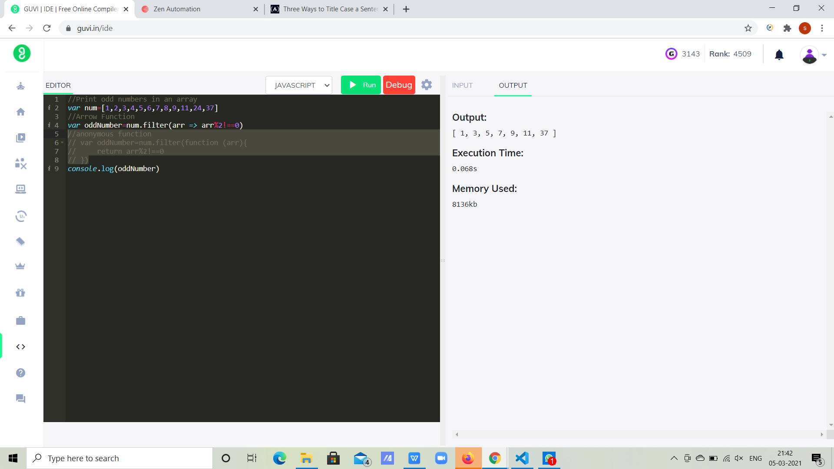

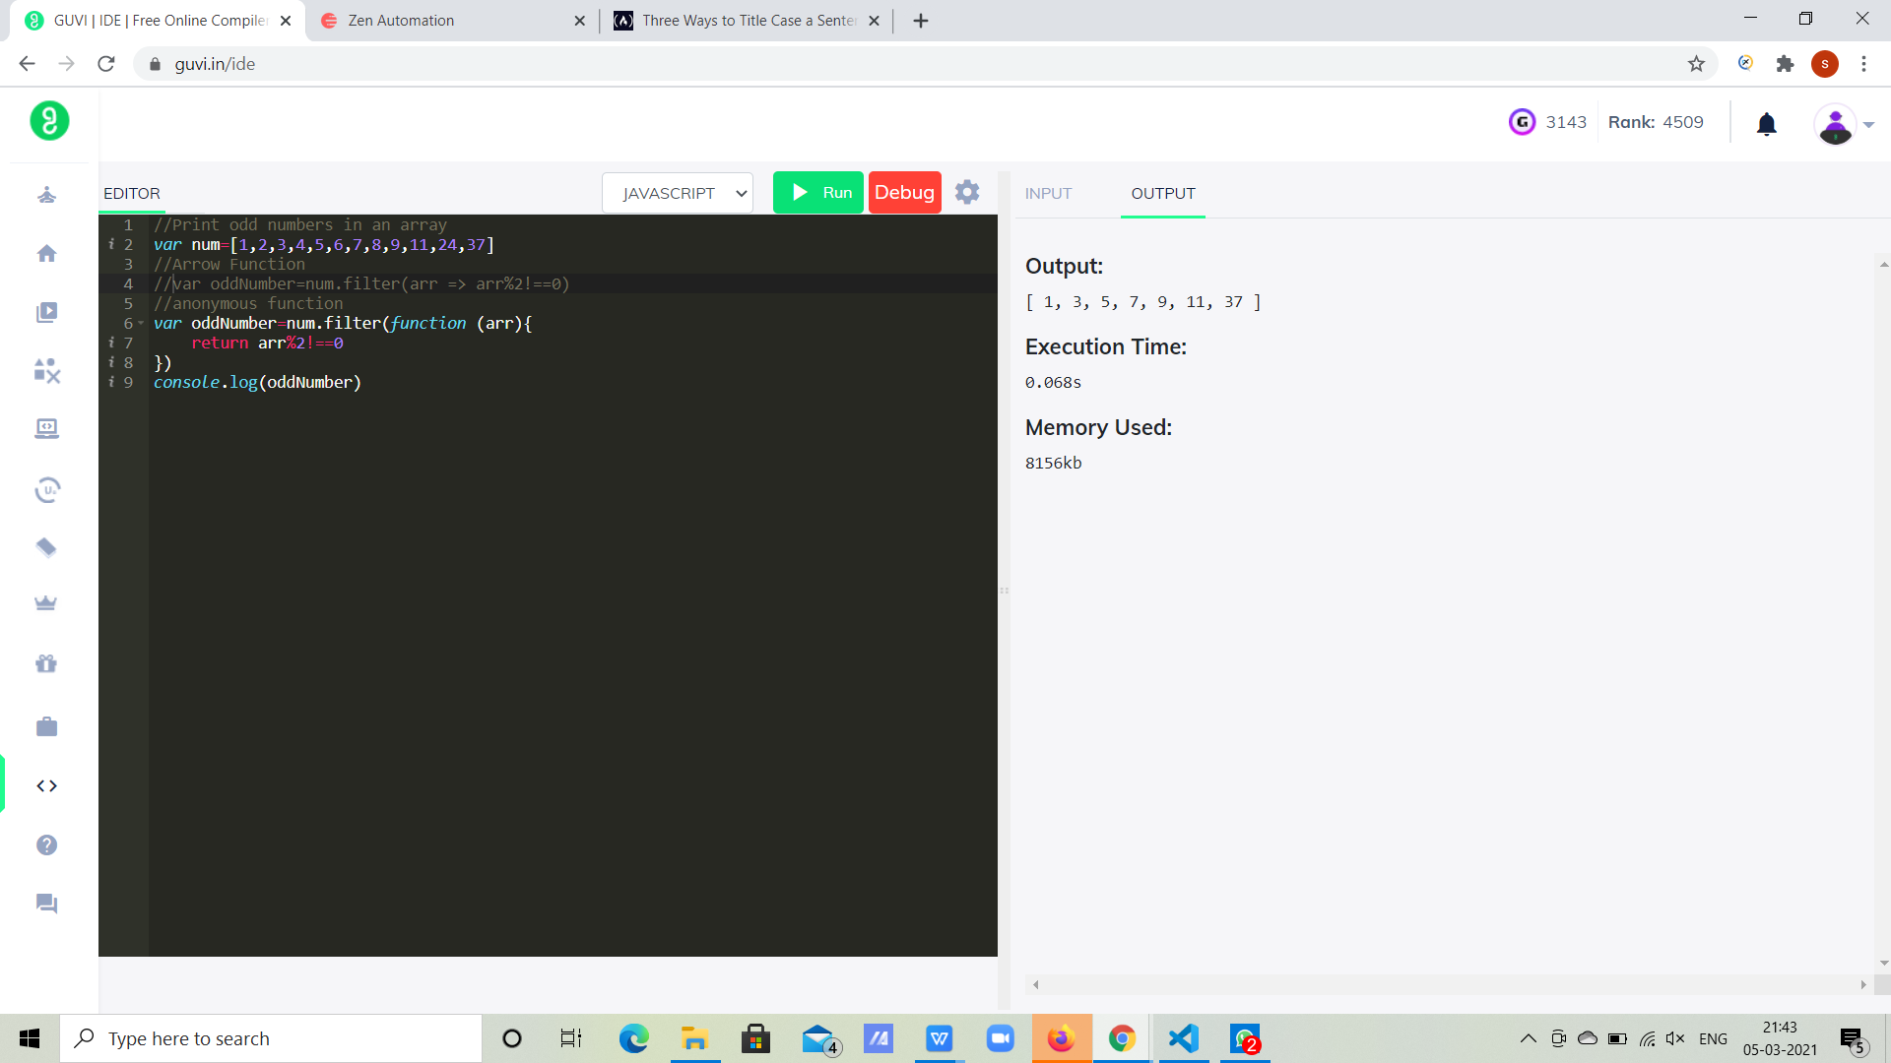

**Question2:** Convert all the strings to title caps in a string array

**Solution:**

**//Arrow function**

var str =['Dog','elephant','lion','tiger','hyena','wolf'];

var strTitleCaps = str.map(item =>item[0].toUpperCase() + item.slice(1));

console.log(strTitleCaps);

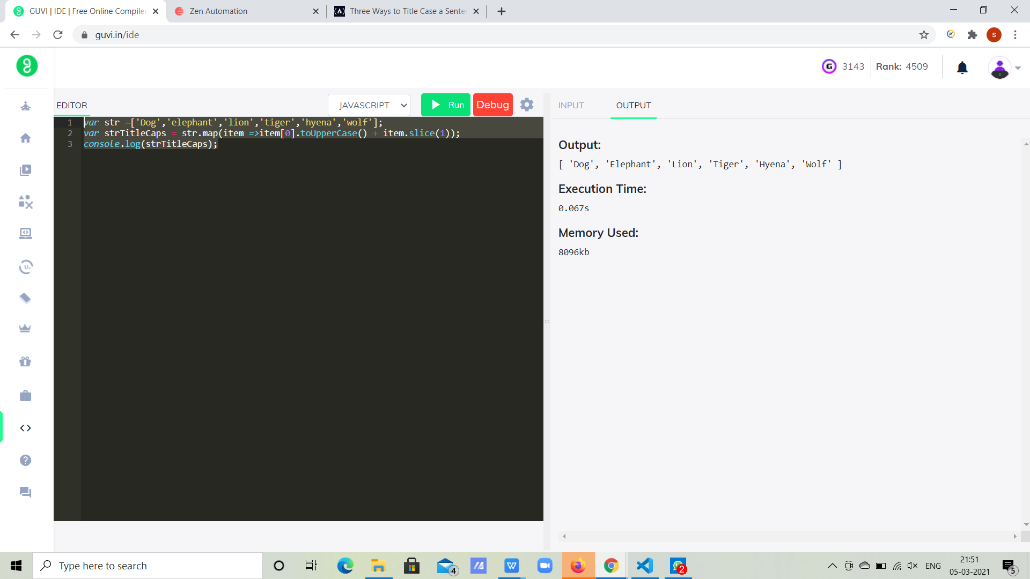

**//Anonymous function:**

var str="I'm a small tea pot"

var str1= str.toLowerCase().split(' ').map(function(word) {

return (word.charAt(0).toUpperCase() + word.slice(1));

}).join(' ');

console.log(str1)

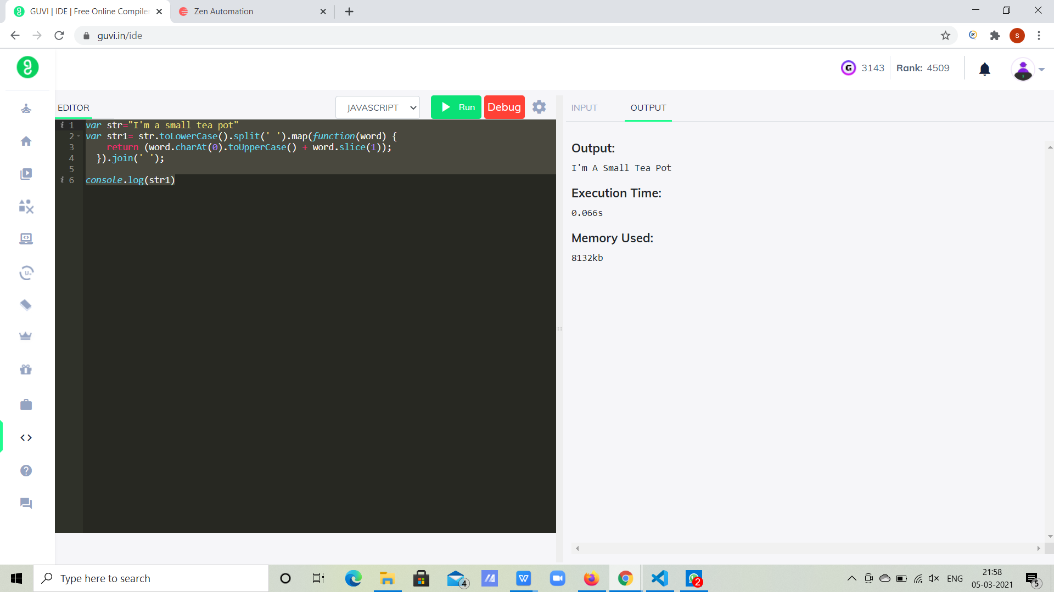

**Question3**: Sum of all numbers in an array

**Solution:**

var num1 = [1,6,3,5,9,1]

**//anonymous function**

var sum=num1.reduce(function (accumulator,currentValue){

return accumulator+currentValue

},0)

**//Arrow Function**

var sum=num1.reduce((accumulator,currentValue) => accumulator+currentValue,0)

console.log(sum)

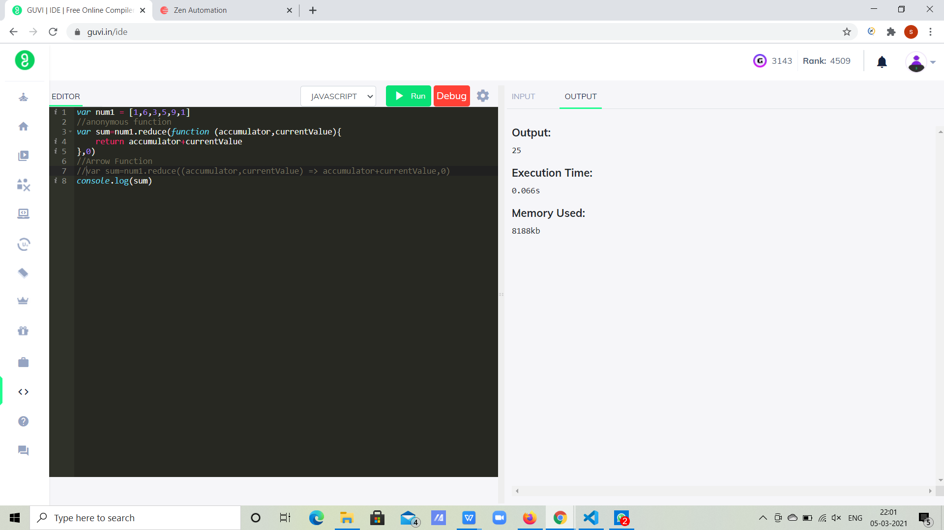

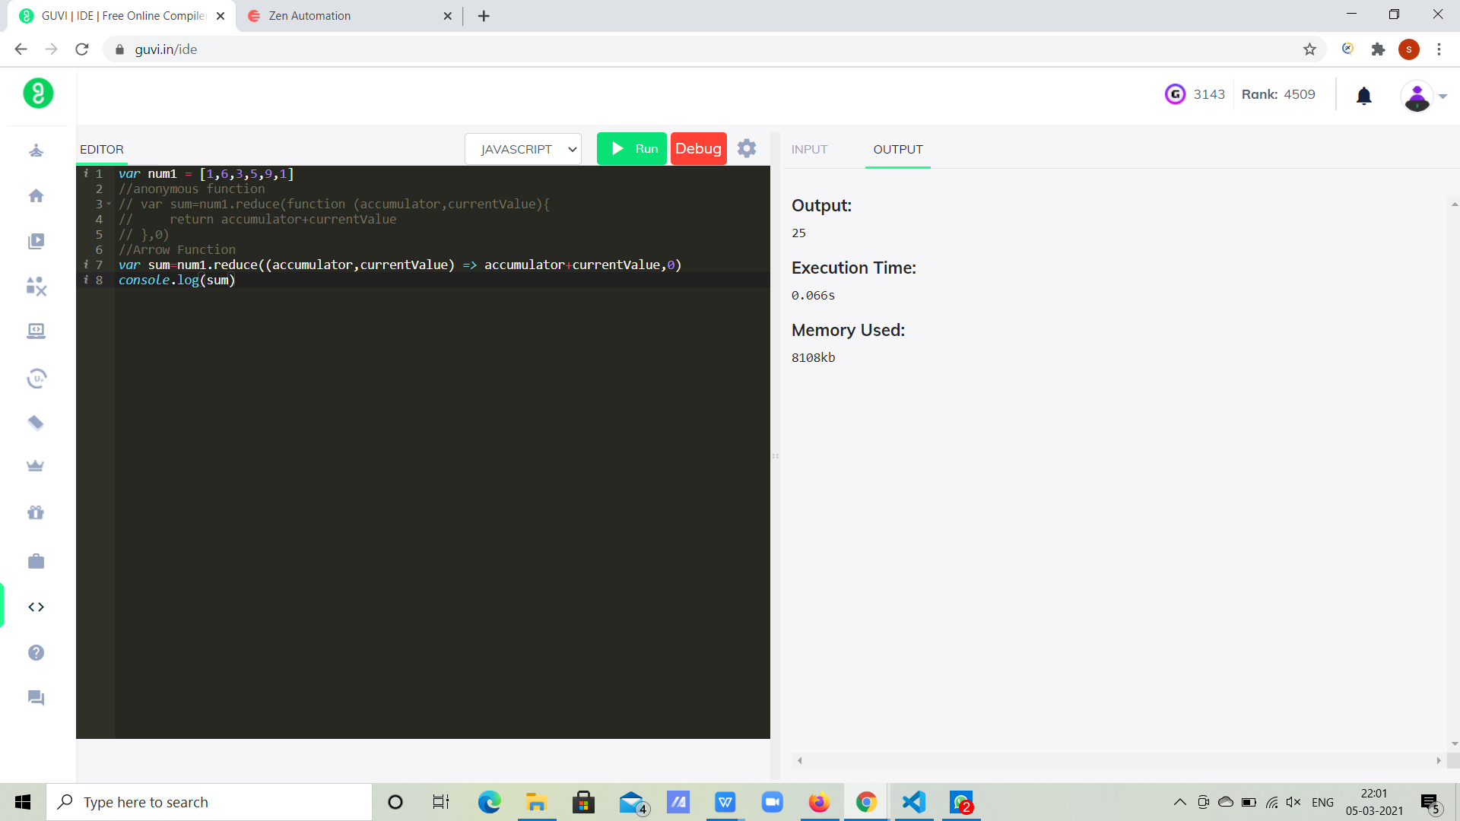

**Question4:** Return all the prime numbers in an array

**Solution:**

**//Anonymous function:**

var num = [2, 3, 4, 5, 6, 7, 8, 9, 10]

var primenumber= num.filter(function (number) {

for (var i = 2; i <= Math.sqrt(number); i++) {

if (number % i === 0)

return false;

}

return true;

});

console.log(primenumber);

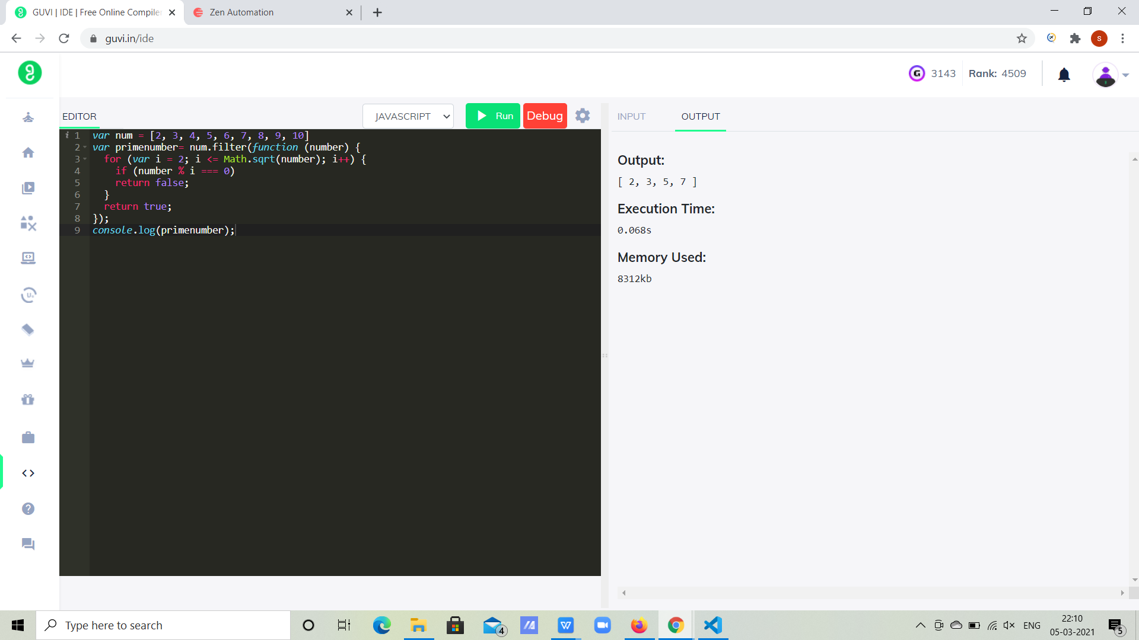

**//Arrow function**

var isprime = (num) => {

if(num<2){

return false;

}

for(i=2;i<num; i++){

if(num%i===0){

return false;

}

}

return true;

}

console.log(isprime(15));

console.log(isprime(37));

console.log(isprime(5));

console.log(isprime(19));

console.log(isprime(27));

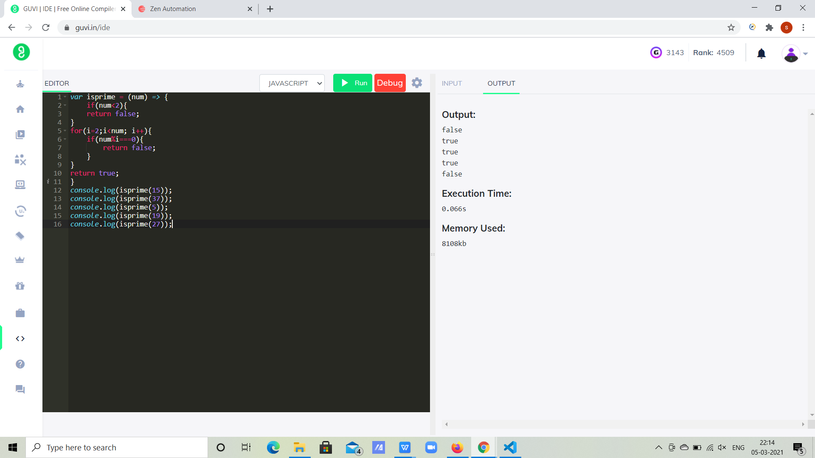

**Question5:** Return all the palindromes in an array

**Solution:**

**//Arrow Function:**

var paliandrome =(str) => {

return str === str.split('').reverse().join('');

}

console.log(paliandrome('racecar'))

console.log(paliandrome('madam'))

console.log(paliandrome('Satheesh'))

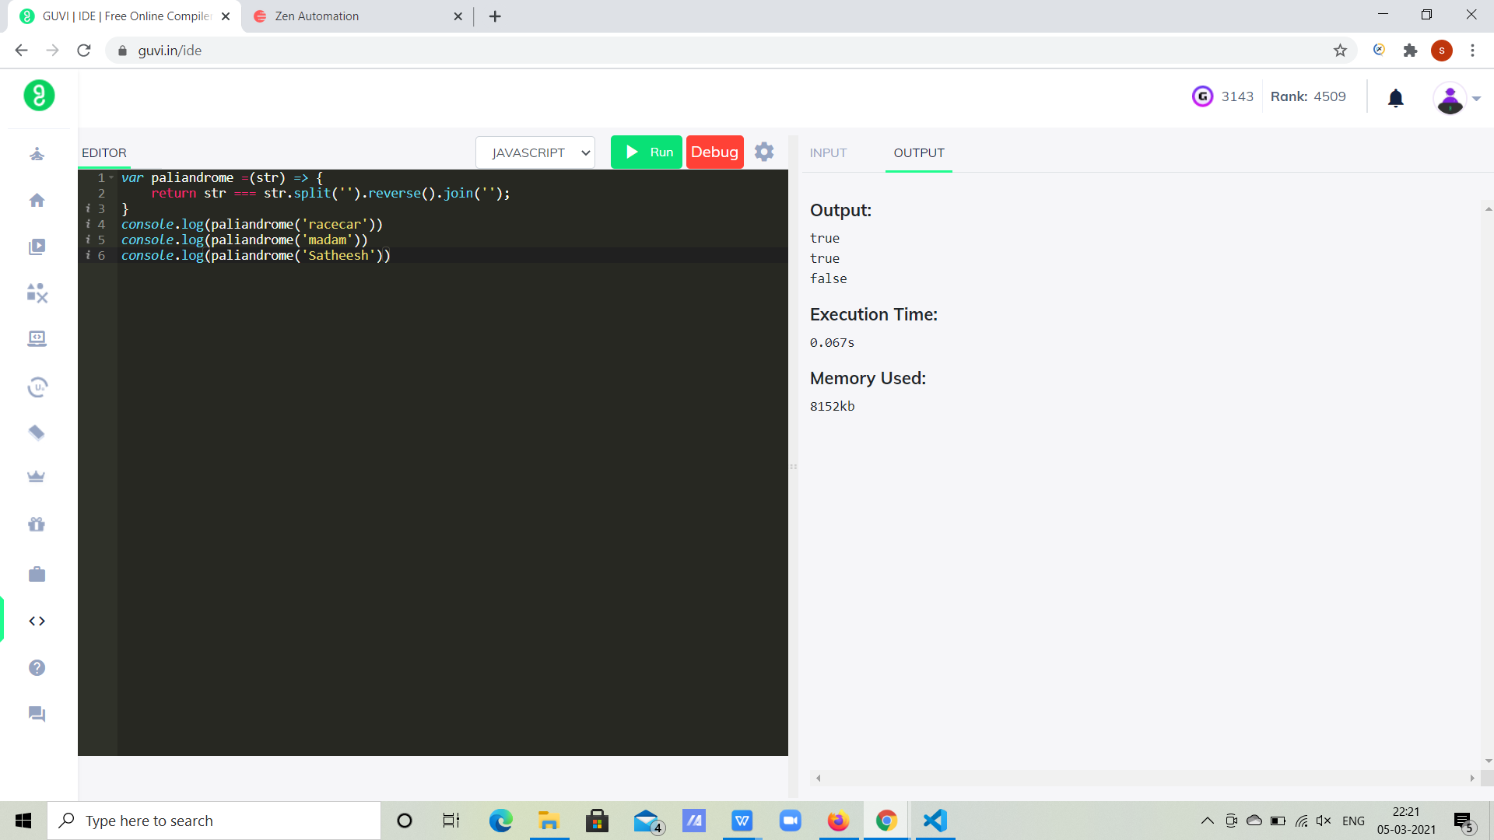

**//Anonymous Function:**

var str = ['mom', 'dood', 'brother'];

var result = str.map(function(item) {

return item.split('').reverse().join('') === item;

});

console.log(result)

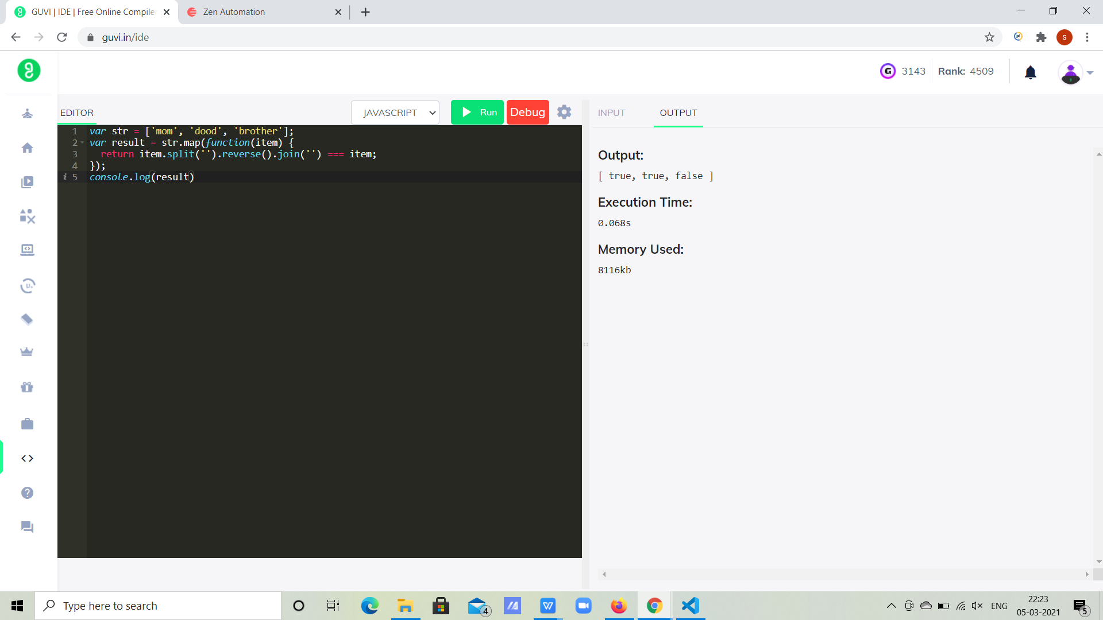

**Question6:** Return median of two sorted arrays of same size

**Solution:**

var a=[1,3,5,7,9];

var b=[2,4,6,8,10];

var c=[...a,...b];

c.sort((a, b) => a - b)

var d=Math.floor(c.length/2)

var median= c=>{

return c.length%2===0 ? c[d-1]+c[d] : c[d]

}

console.log(median(c)/2)

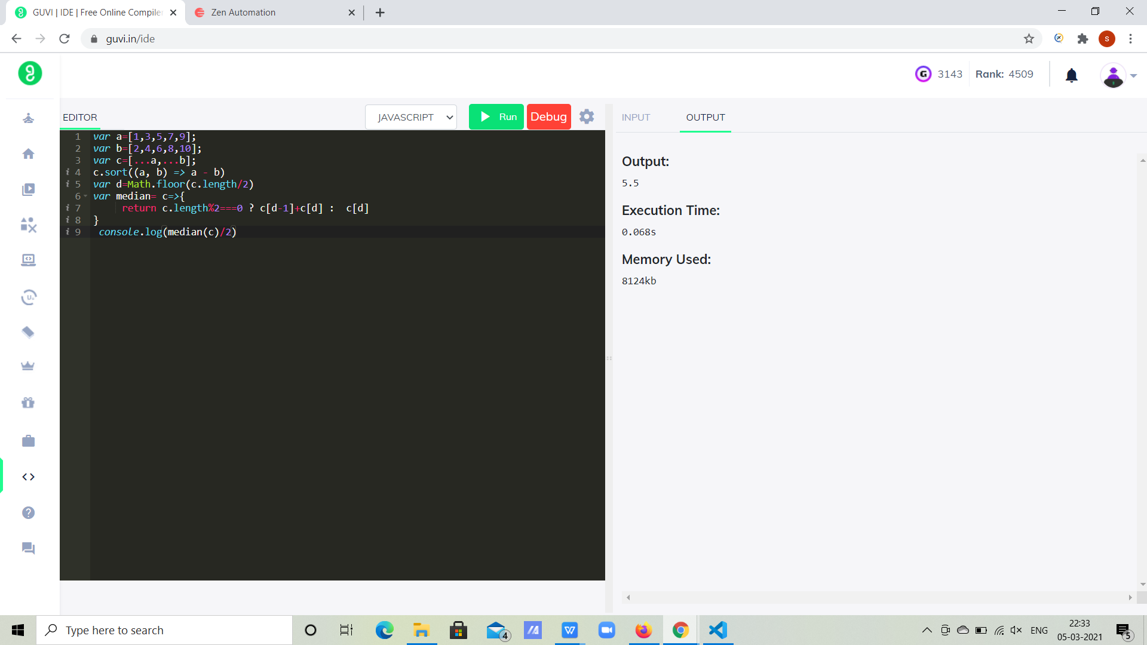

**Question7:** Remove duplicates from an array

**Solution:**

**//Anonymous Function:**

var cities = ["Chennai","Mumbai","Delhi","Hyderabad","Mumbai","Chennai","Delhi","Bangalore"]

var nonDuplicate = cities.filter(function(element,index){

return cities.indexOf(element)===index;

});

console.log(nonDuplicate)

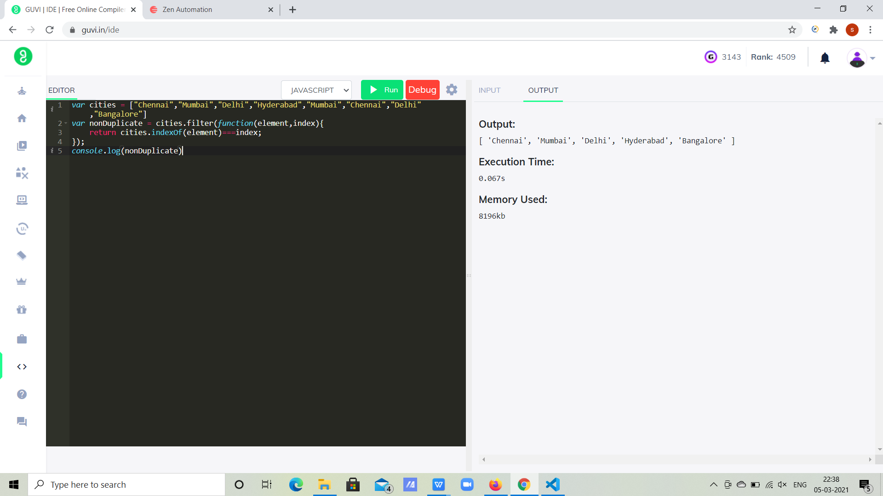

**//Arrow Function:**

var food = ["Pizza","Burger","Biryani","Friedchicken","Biryani","Pulao","Burger"]

var nonDuplicate = food.filter((element,index)=>{

return food.indexOf(element)===index;

});

console.log(nonDuplicate)

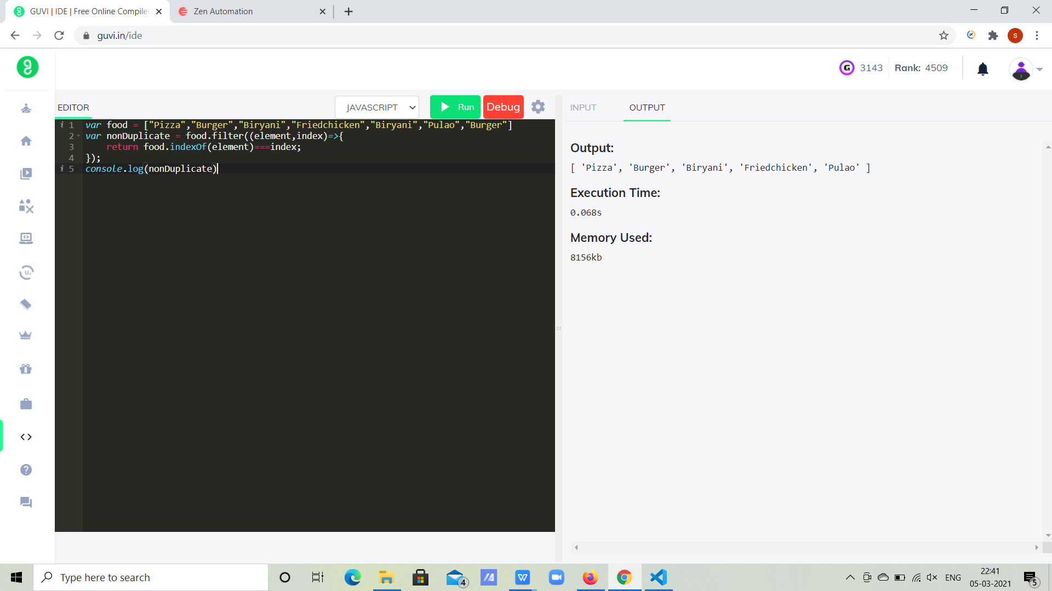

**Question8:** Rotate an array by k times and return the rotated array

**Solution:**

var numbers= [1,2,3,4,5,6,7];

var k=3;

var rotate = (nums, k) => {

for (let i = 0; i < k; i++) {

nums.unshift(nums.pop());

}

return nums;

}

console.log(rotate(numbers,k));

